**Headline 1**

**Headline 2**

**Headline 3**

Paragraph, Link, Button text

**Button Alt**

Disclaimer, CardTitle, CardMessage

Breadcrumb

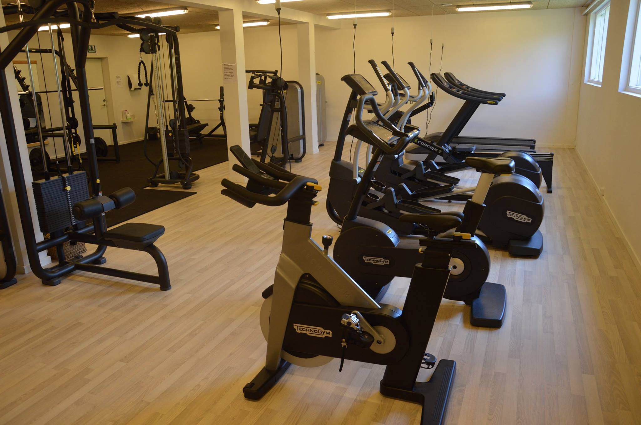

**HEX** #0F2132

**RGB** 15 33 50

**CMYK** 70 34 0 80

**HEX** #006699

**RGB** 0 102 153

**CMYK** 100 33 0 40

**HEX** #0FA0CE

**RGB** 15 160 206

**CMYK** 92 22 0 19

**HEX** #68ADCF

**RGB** 104 173 207

**CMYK** 50 16 0 19

**HEX** #148D04

**RGB** 20 141 4

**CMYK** 86 0 97 45

**HEX** #800000

**RGB** 128 0 0

**CMYK** 0 100 100 50

**HEX** #111111

**RGB** 17 17 17

**CMYK** 0 0 0 93

**HEX** #666666

**RGB** 102 102 102

**CMYK** 0 0 0 60

**HEX** #888888

**RGB** 136 136 136

**CMYK** 0 0 0 47

**HEX** #CCCCCC

**RGB** 204 204 204

**CMYK** 0 0 0 20

**HEX** #EEEEEE

**RGB** 238 238 238

**CMYK** 0 0 0 7